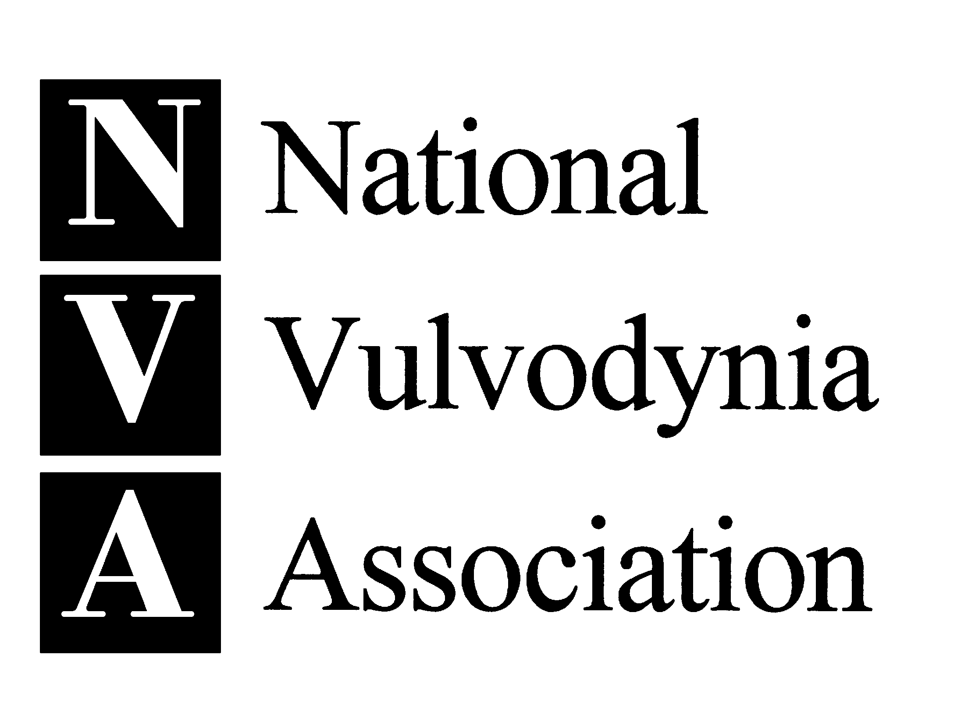

Sample Letter to Legislator

Date

The Honorable [First and Last Name]
Address
City, State, Zip

Dear [Representative OR Senator] [Last Name],

As a member of your district, I am requesting your assistance in dealing with a major unmet women’s health care need.

Many hard-working voters in our community, including myself, suffer from chronic vulvar pain without an identifiable cause, a condition known as vulvodynia. Preliminary prevalence data from a study funded by the National Institutes of Health indicates that six million American women suffer from vulvodynia. Sixty percent of patients report visiting three or more health care providers to obtain a diagnosis and an astounding 40 percent remain undiagnosed (Harlow BL, Stewart EG, JAMWA, 2003).

Include a few sentences on your own history here… (for example, ## of doctors visited, effect on our quality of life and ability to work/care for family, # of treatments and consequences of treatments)

Your help is urgently needed to advocate for increased allocation of federal research funding for vulvodynia. Left unaddressed, this growing public health concern threatens the ability of your constituents to do their jobs and care for their families.

Please contact me to set up a meeting to discuss how we can tackle this important women’s health concern together.

Sincerely,

Your name
Credentials / Affiliations (e.g., Local NVA Support Group Leader)

Your address
Your phone number / email

