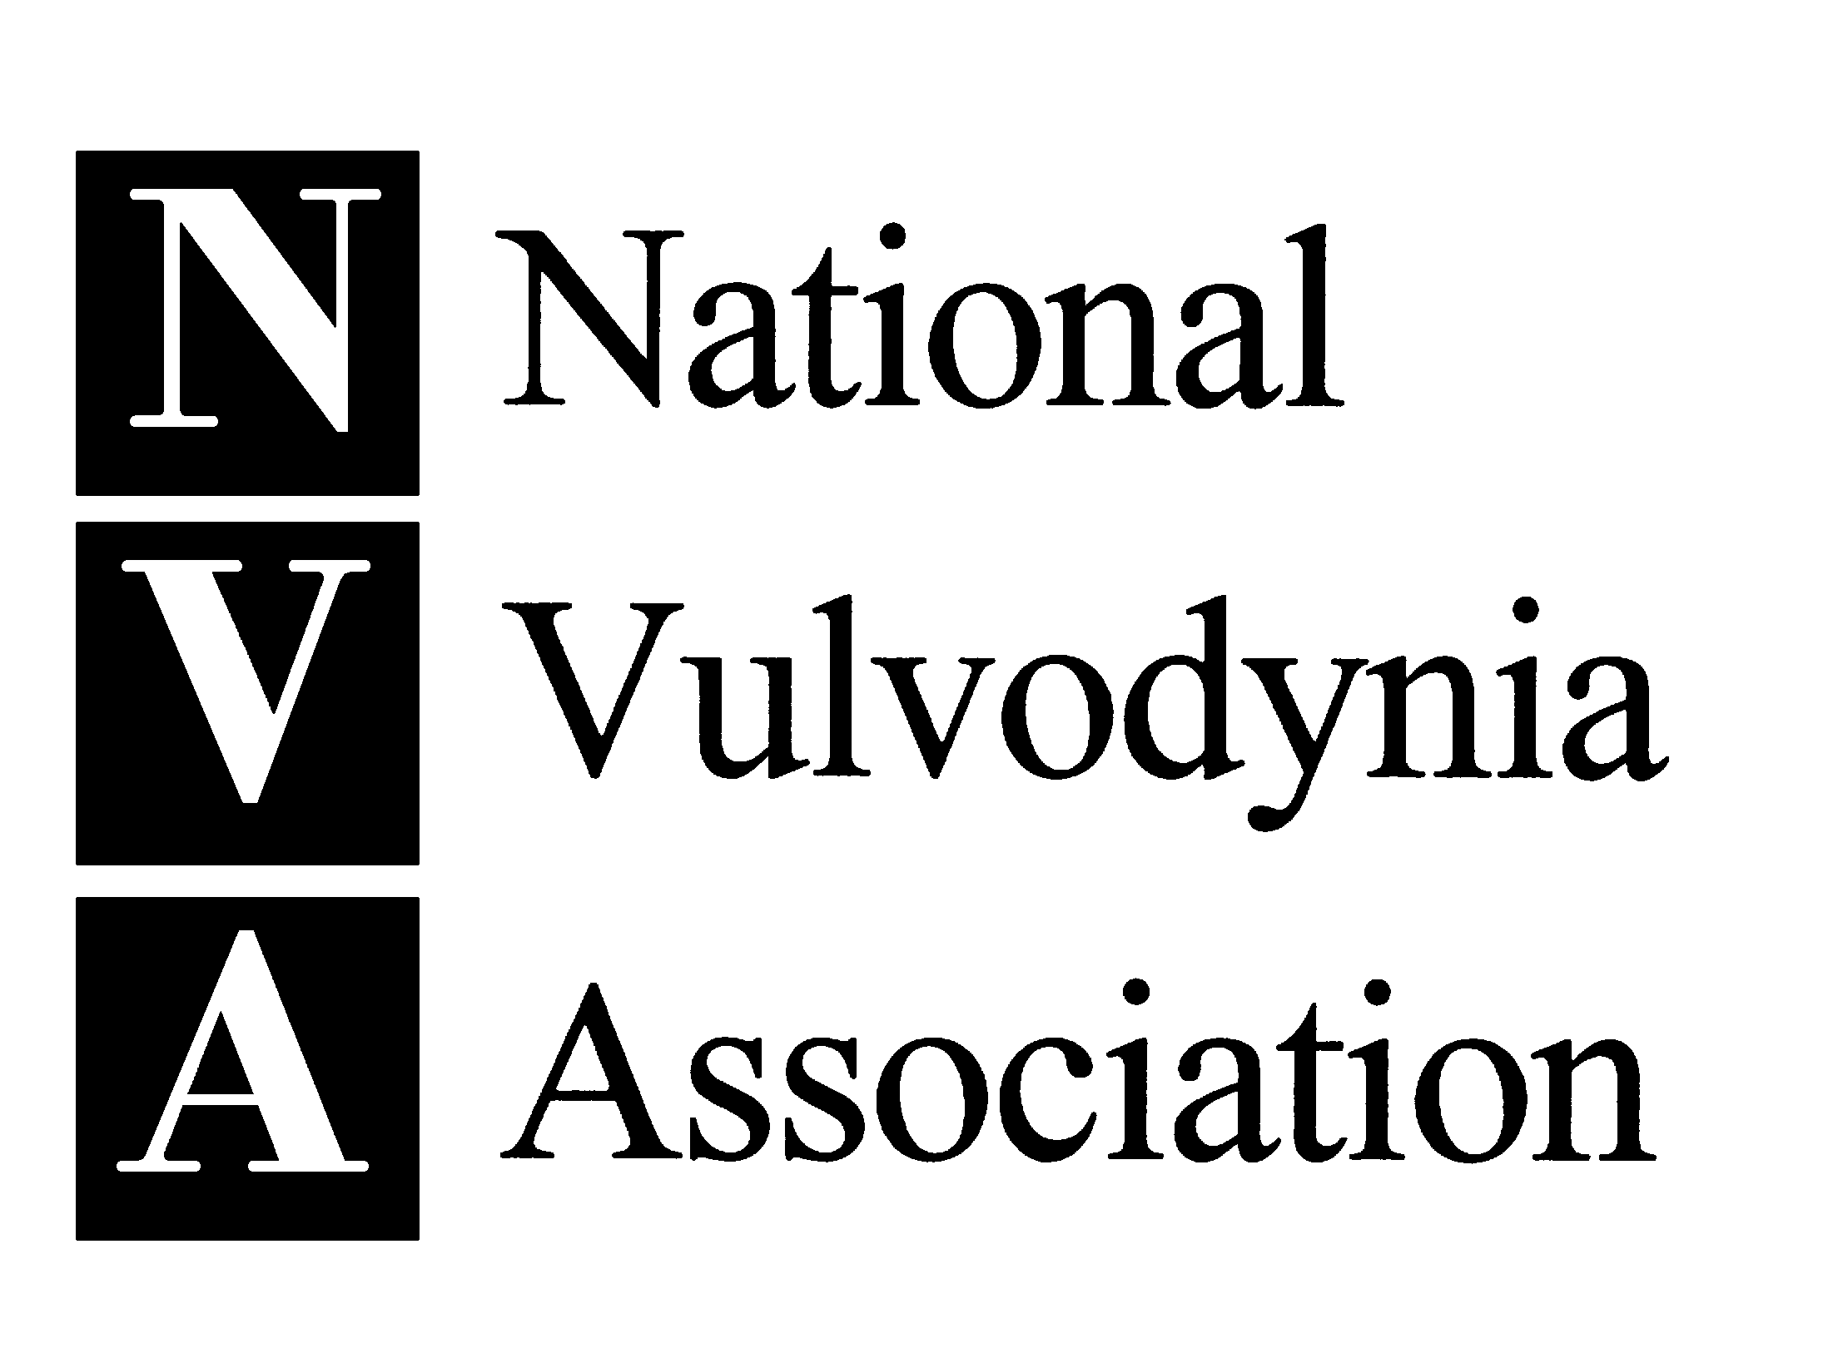

Sample Cover Letter
For educational mailing to local health care provider

Date

Dr. X
Address
Address

Dear Dr. X,

I am writing you to inform you about a widely prevalent and under-recognized women’s pain condition that many women in this area suffer from – vulvodynia. Preliminary prevalence data from an ongoing NIH-funded study at Harvard University indicates that six million American women suffer from vulvodynia, or chronic vulvar pain without an identifiable cause. Sixty percent of patients report visiting three or more health care providers to obtain a diagnosis and an astounding 40 percent remain undiagnosed (Harlow BL, Stewart EG, JAMWA, 2003).

Can include a few sentences on your own history here…

Enclosed please find materials for your review from the National Vulvodynia Association (NVA). The NVA is one of the only organizations in the world dedicated to providing educational and support services to women suffering from chronic vulvar pain and health care professionals who treat vulvar pain patients. We also invite you to visit their web site, www.nva.org, for additional information about the organization and its services.

Sincerely,

Your Name
Your Contact Information

